Istanbul Aydin University

Hasan Sidawi

Instructor: SAJAD EINY

Internet Programming II Final PHP Project



# **Table of Content**

Table of Content 1

Introduction to the Software: 2

What does the software do? 2

Sign-in (as a super-admin): 3

Add/Delete Users: 4

Add/Delete stores: 5

Add/Delete tables: 6

Add/Delete categories: 6

Add/Delete products: 7

Add/Delete orders: 7

What makes this software good? 8

UML Diagram (PROCESS FLOW): 8

# **Introduction to the Software:**

This project “Restaurant Cashier System” is a system, based on **PHP** platform, for a restaurant cashier system that can be accessed by the staff of the restaurant branches, branch managers, and even super-admins. Branch managers and staff account can be **Created** online, then the new accounts can be opened by their users. Staff in the system can Log-in. Then **Add, Edit orders** in the database and **approve payment** of customers. The branch manager can edit the tables in the branch that he manages, add or delete orders.

The software handles all operations between website and database (Using **MySQL** platform) like **inserting** into the database or **deleting** from it. Also, **searching** functions are applied there. Also, dishes can be added int the system using the accounts of managers, for them to make new types of food to cater for customers.

# **What does the software do?**

This website, that runs a system of cashier, has the following functions:

1. Sign-in.
2. Add/Delete users.
3. Add/Delete stores.
4. Add/Delete tables.
5. Add/Delete categories.
6. Add/Delete products.
7. Add/Delete orders.

## **Sign-in (as a super-admin):**

Sign-in into the website as a super-admin for the first time. Then you can create other users. The sign-in data are: Username: admin@admin.com, password: password.

You can access Sign-in using Master page:

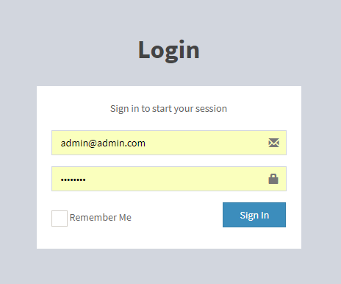

Figure 1 Master Page

Then you will see the index page:

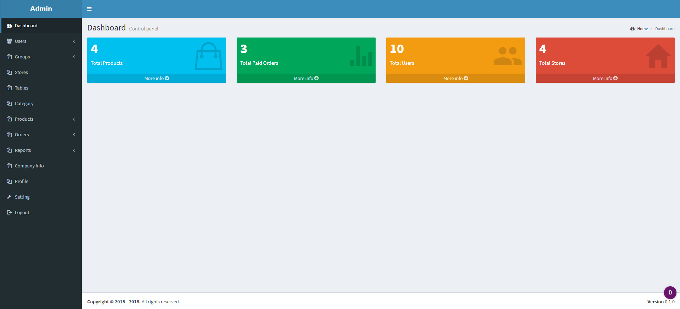

Figure 2 Sign-up Page

## **Add/Delete Users:**

Click on the users’ label, then “Add User” to create new user:

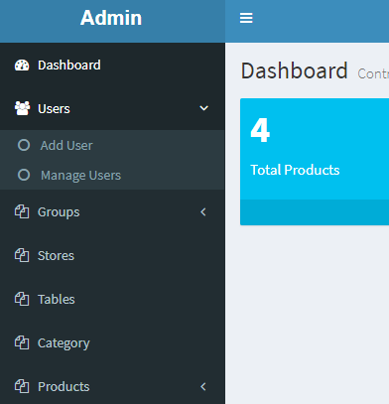

Fill the boxes to create the needed user:

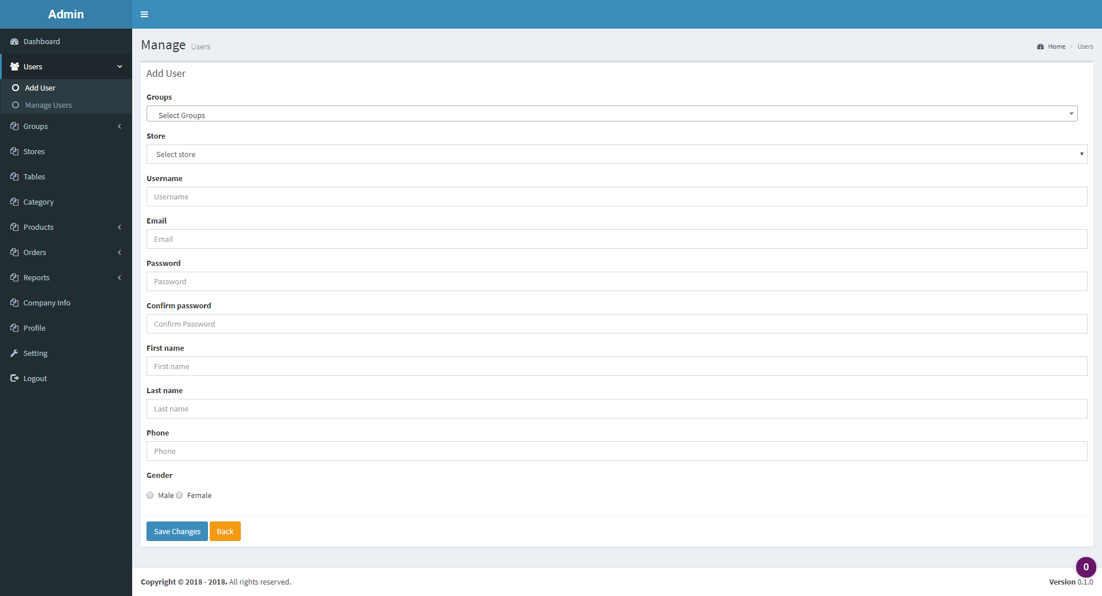

Or delete users, using “Manage Users” label, then click on trash icon beside the user.

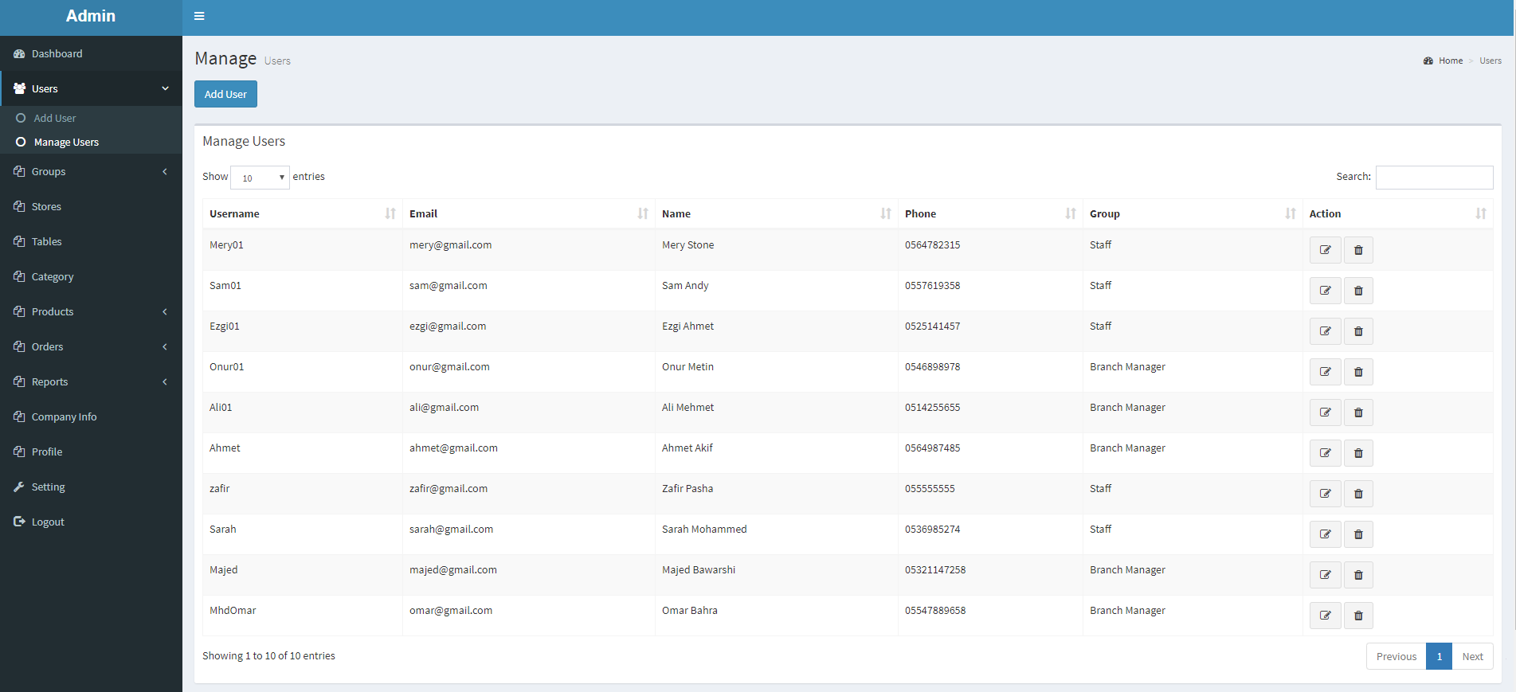

## **Add/Delete stores:**

Super admin can add/delete stores (branches) in the system:

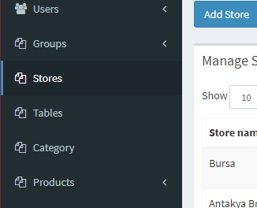 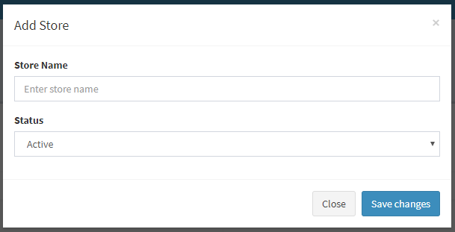

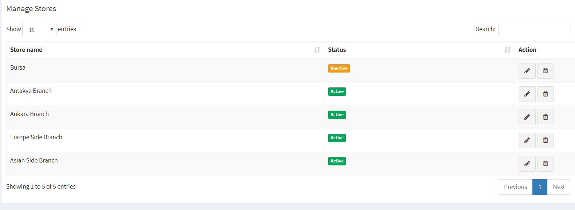 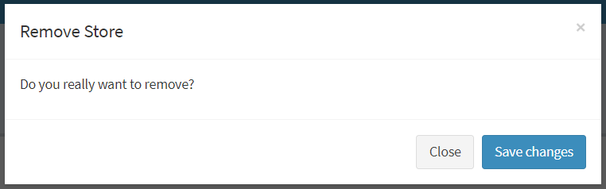

## **Add/Delete tables:**

Adding or deleting tables is a feature that can be accessed using both: super-user or branch manager user. Follow the bellow screenshots to get an idea about how to use the function:

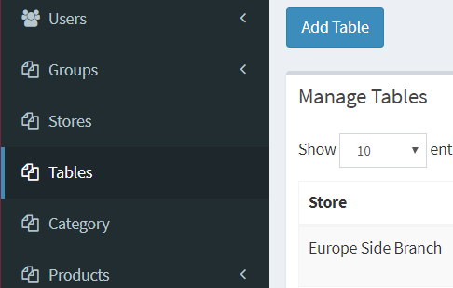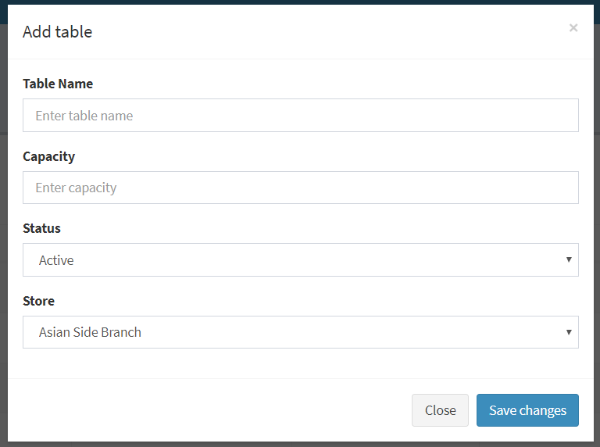

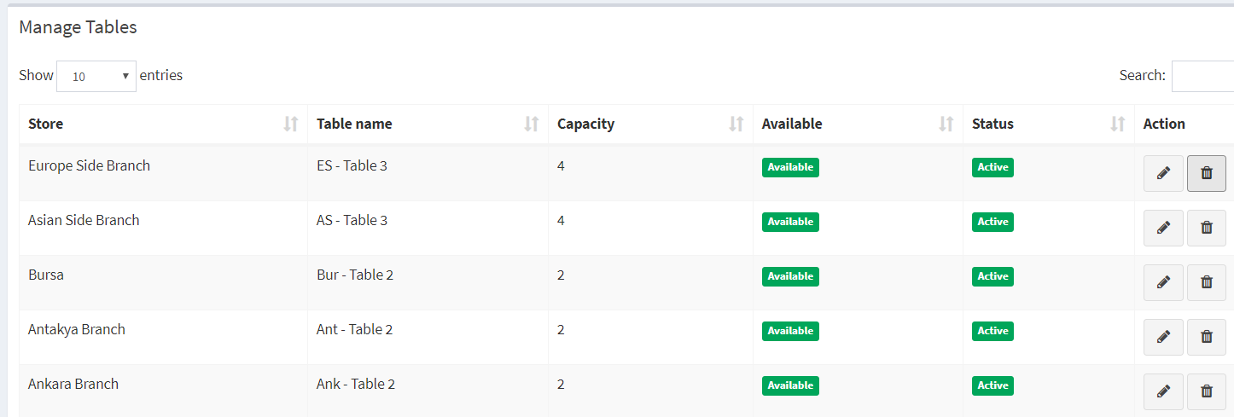

## **Add/Delete categories:**

Add/Delete category (food type. ex. Chicken, soup…) of products can be done using the users of super-admin and branch manager:

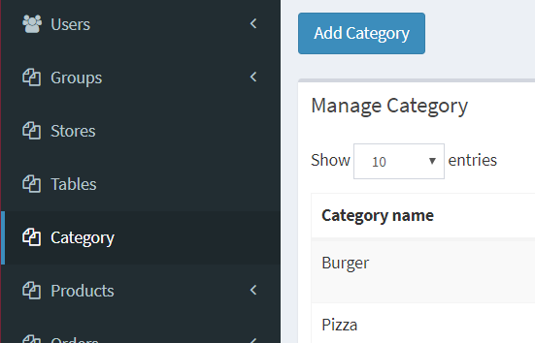 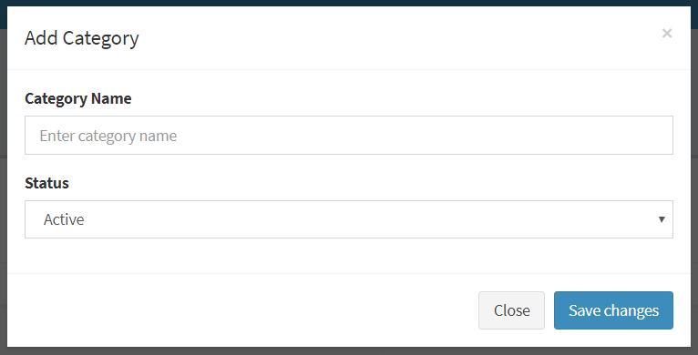

## **Add/Delete products:**

Add/Delete products (meals) at any branch can be done using the users of super-admin and branch manager:

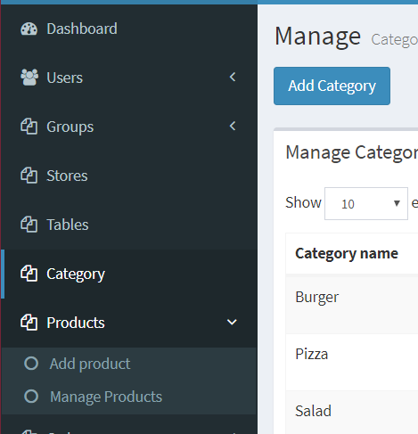 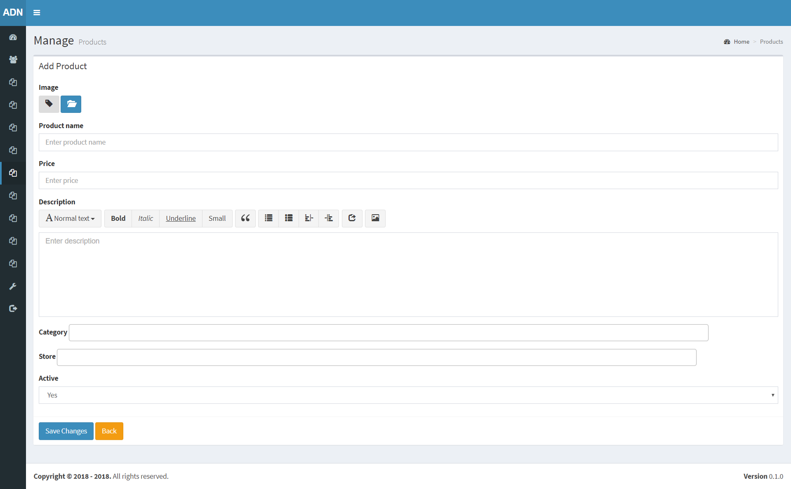

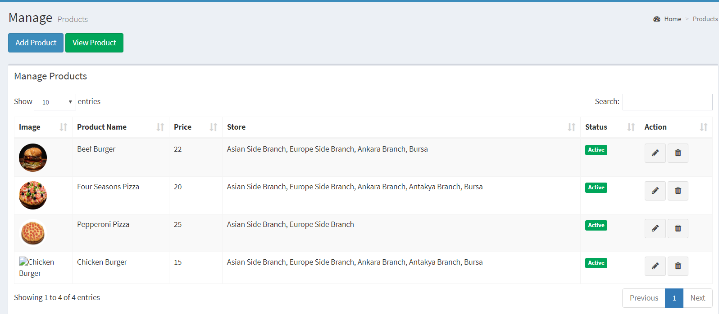

## **Add/Delete orders:**

Add/Delete orders (meals) at any branch can be done using the users

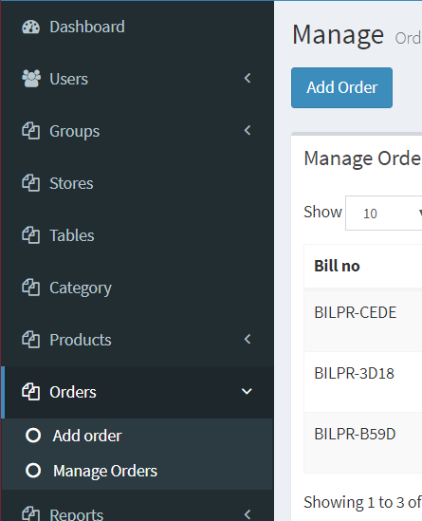 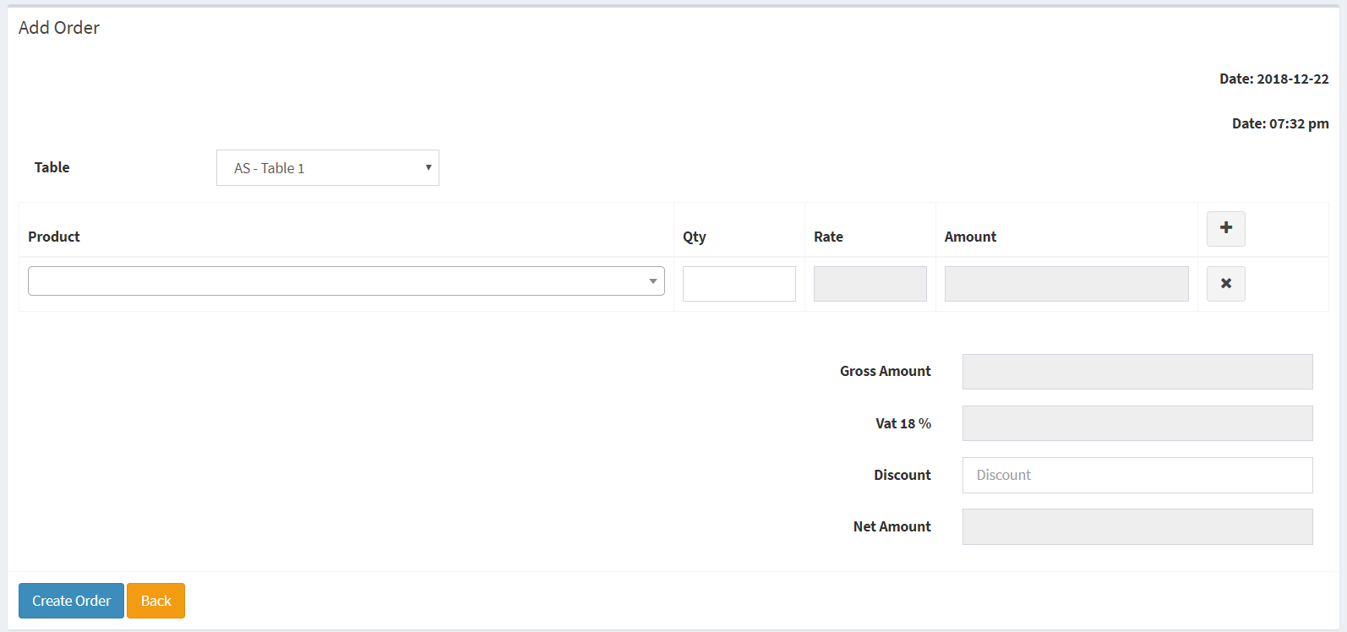

# **What makes this software good?**

It has many good points:

1. Simple Design.
2. Usable functions.
3. Reasonable interface.
4. Dynamic categories of admins, branches, stores, and tables.
5. High security performance using sessions abilities.
6. Design made with MVC principles, so that make the system much more professional.

# **UML Diagram (PROCESS FLOW):**

